-

Life on Earth |  | Year 6 |  |  | Unit 4
Assessment task — Investigating activation growth
Name |  |  | Class
Teacher |  |  | Date

Task
You will plan, conduct and evaluate an investigation to identify the best environment to grow dough containing yeast
Instructions
Part A: Plan an investigation about yeast activation
Part B: Observe, record and analyse results
Conditions
There are opportunities in this assessment task for group work and discussion, and for individual work.
Group work and discussion |  | Individual work | 
The assessment task is to be completed in this booklet under test conditions.
Each student will complete an individual assessment booklet.
Read and respond to the questions carefully.

Scenario
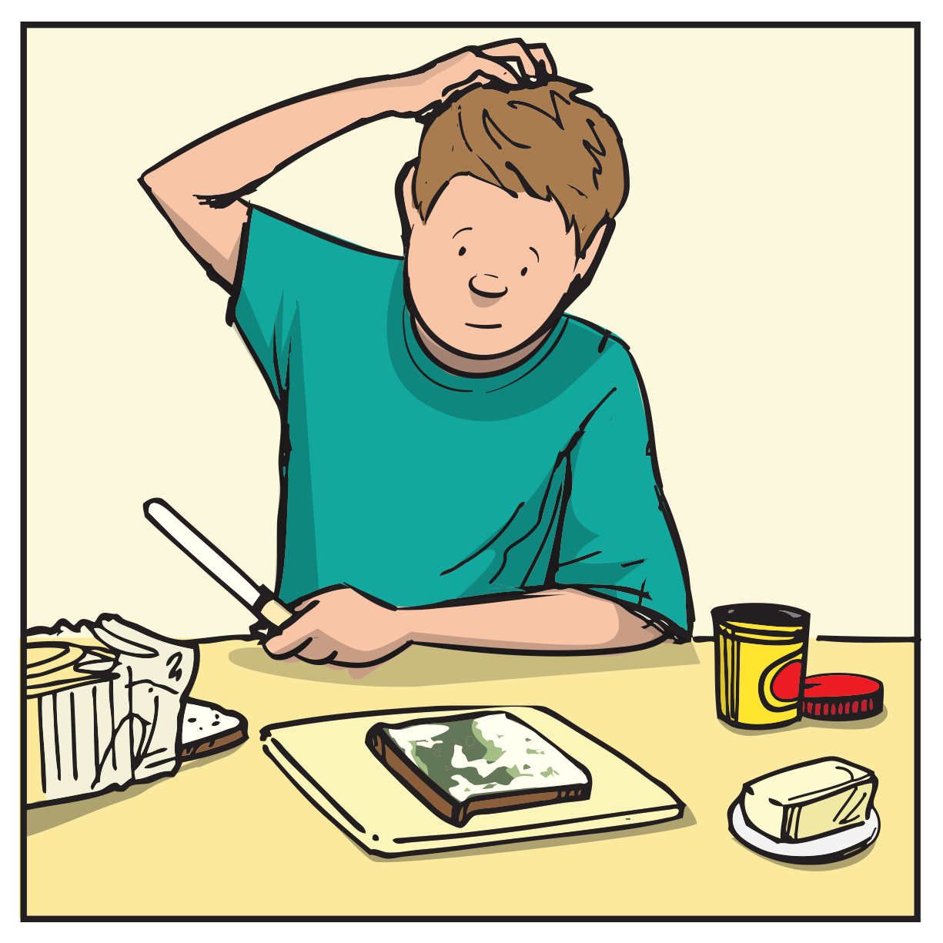
Samantha is a baker who loves to make bread from scratch. She recently noticed that her bread dough wasn't rising as much as it usually did and upon closer inspection, she found that there was a minimal growth of yeast in the dough.
Samantha is frustrated because she has to start over with a new batch of dough and she'll be behind on her bread orders.
She wants to know the best conditions for yeast activation when making bread dough, so she can ensure that her bread rises to perfection every time.
Part A: Plan an investigation about mould growth
You will plan, conduct and evaluate an investigation to identify factors that affect yeast activation.
Your teacher will provide your group with the ingredients for your investigation.
You will measure yeast activation time.
Plan
 | - a) Record all the variables that could affect the amount of mould growth in the variable grid.
The amount of
mould growth
 | b) On the variables grid.  - Label the variable you will measure with (M)  - Circle the variable that you will change and label with (C)  - Label the variables you will keep the same with (S).
 | - Complete your investigation question.  What happens to  when

 | - Complete your prediction about mould growth in this investigation.  If  then  because
- Materials and equipment
3 equal portions of plain flour
3 A4 pieces of paper with 1cm grids printed on it
Digital Scales
Stop watch
1 plastic plate

 | - Describe potential safety risks and suggest how these risks could be reduced. Record your description in a table using the headings shown.  Potential risk How risk can be reduced


Method
 | - List the steps you will follow to complete your investigation. You will need to consider how you will determine the amount of veast growth.  - Collect your materials and equipment.
 | Remember: After your resealable sandwich bags are taped shut, they must not be opened again.
Conduct
 | - Conduct the investigation
Part B: Observe, record and analyse results
Observations
 | - Record and organise your ongoing data and observations throughout the investigation on the following pages.  - Record observations of each bread sample on the grids.  Record white mould by drawing a circle in the square where it appears.  Other coloured mould should be recorded by drawing a circle and colouring appropriately.  - Note any other observations.  Describe the appearance of the bread and mould for each sample

Yeast specimen : 1
- Measure the time taken for the yeast to activate.

Change | Time taken to activate

 | - Construct a side-by-side column graph that represents data from the weight. Remember to:  give the graph a title  label the horizontal and vertical axes  use different colours to represent data  include a legend.

Change

Explain
 | - Using the graph, describe and analyse the amount of yeast activation from the 3 samples.
 | - Identify ways Samantha could help her yeast to activate when she makes bread in the future. Justify your choice using your science knowledge and data from your investigation.

Year 6 Science: Unit 4 — Life on Earth: Investigating mouldy bread | Name:
Purpose of assessment: To develop an investigable question and design an investigation into simple cause-and-effect relationships including identifying variables to be changed and measured and potential safety risks. To collect, organise and interpret data to identify environmental factors that contribute to mould growth in bread and explain how scientific knowledge helps to solve problems.
Science Understanding |  |  | Science Inquiry Skills
Biological sciences |  |  | Questioning and predicting  Planning and conducting |  |  |  |  | Processing and analysing  data and information |  |  |  | Communicating
Describe and predict the effect of environmental changes on individual living things. |  |  | Follow procedures to develop investigable questions. Design investigations into simple cause-and-effect relationships. Identify variables to be changed and measured, and describe potential safety risks when planning a method. |  |  |  |  | Collect, organise and interpret their data. Describe and analyse relationships in data using appropriate representations. |  |  |  | Construct multimodal texts to communicate ideas, methods and findings.
 |  | Applies scientific knowledge to justify predicted and identified environmental factors. |  |  |  | Plans and conducts a logical investigation using scientific understanding. |  |  |  | Accurately organises and interprets qualitative and quantitative data. Uses data to justify best storage option. |  |  |  | Communicates using accurate scientific language and appropriate representations comprehensively. | A
 |  | Links individual environmental factors identified to yeast growth. |  |  |  | Clearly links the investigation to the posed investigation question. |  |  |  | Uses results as evidence when developing explanations. |  |  |  | Communicates ideas using scientific language and representations. | B
 |  | Describes and predicts an environment that will affect the amount of yeast growth. |  |  |  | Follows procedures to develop investigable questions. Designs an investigation into simple cause-and-effect relationships. Identifies variables to be changed and measured, and describes potential safety risks when planning a method. |  |  |  | Collects, organises and interprets data. Describes and analyses relationships between mould growth and environment using graphic representations. |  |  |  | Constructs multimodal texts to communicate ideas, methods and findings. | C
 |  | Identifies an environmental factor that affects yeast growth. |  |  |  | Identifies a potential safety risk. |  |  |  | Collects data with guidance. |  |  |  | Uses everyday language. | D
 |  | Suggests where to store food. |  |  |  | Poses a question. |  |  |  | Records an observation. |  |  |  | Uses fragmented language. | E

Feedback:

